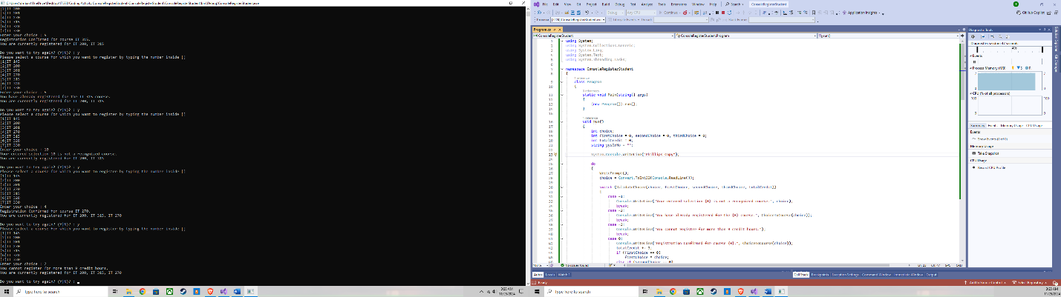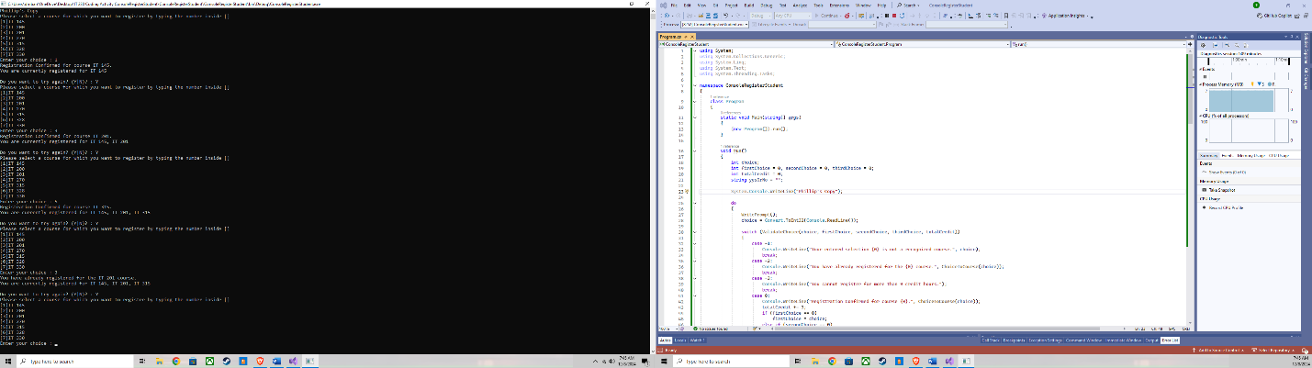

The above screen shots are the outcome of the program running correctly as asked, adding two screen shots to show each number input as requested:

1. The student enters only integers to select courses for registration. No validation of the type of user input (e.g., Is it a string?) is checked or required.
2. Each course carries three credit hours.
3. The program terminates only when the student requires it.
4. The program must follow these registration business rules:
5. No registration of other courses not displayed by the program
6. No registration more than once for the same course
7. No registration for more than nine credit hours (e.g., no more than three courses)

To further explain what was fixed (which was a bit sneaky to say the least):

The original code had an issue with checking if a course was already registered. It incorrectly used && (logical AND) instead of || (logical OR) to check all three choices. I updated it to properly check if the chosen course was already registered (if (choice == firstChoice || choice == secondChoice || choice == thirdChoice)).

The program incorrectly allowed more than 9 credit hours to be registered. I fixed this by changing the condition to ensure that the total credits do not exceed 9 (if (totalCredit >= 9)). The original code had a return -4 that was misleading. I updated it to return 0 for successful registration, which allowed the code to handle course registration properly. I adjusted messages to clearly guide the user through the registration process, including showing which courses they are already registered for after each registration attempt.

Debugged code:  
using System;

using System.Collections.Generic;

using System.Linq;

using System.Text;

using System.Threading.Tasks;

namespace ConsoleRegisterStudent

{

class Program

{

static void Main(string[] args)

{

(new Program()).run();

}

void run()

{

int choice;

int firstChoice = 0, secondChoice = 0, thirdChoice = 0;

int totalCredit = 0;

string yesOrNo = "";

System.Console.WriteLine("Phillip's Copy");

do

{

WritePrompt();

choice = Convert.ToInt32(Console.ReadLine());

switch (ValidateChoice(choice, firstChoice, secondChoice, thirdChoice, totalCredit))

{

case -1:

Console.WriteLine("Your entered selection {0} is not a recognized course.", choice);

break;

case -2:

Console.WriteLine("You have already registered for the {0} course.", ChoiceToCourse(choice));

break;

case -3:

Console.WriteLine("You cannot register for more than 9 credit hours.");

break;

case 0:

Console.WriteLine("Registration Confirmed for course {0}.", ChoiceToCourse(choice));

totalCredit += 3;

if (firstChoice == 0)

firstChoice = choice;

else if (secondChoice == 0)

secondChoice = choice;

else if (thirdChoice == 0)

thirdChoice = choice;

break;

}

WriteCurrentRegistration(firstChoice, secondChoice, thirdChoice);

Console.Write("\nDo you want to try again? (Y|N)? : ");

yesOrNo = (Console.ReadLine()).ToUpper();

} while (yesOrNo == "Y");

Console.WriteLine("Thank you for registering with us");

}

void WritePrompt()

{

Console.WriteLine("Please select a course for which you want to register by typing the number inside []");

Console.WriteLine("[1]IT 145\n[2]IT 200\n[3]IT 201\n[4]IT 270\n[5]IT 315\n[6]IT 328\n[7]IT 330");

Console.Write("Enter your choice : ");

}

int ValidateChoice(int choice, int firstChoice, int secondChoice, int thirdChoice, int totalCredit)

{

if (choice < 1 || choice > 7) // Fixed to validate against correct course numbers

return -1;

else if (choice == firstChoice || choice == secondChoice || choice == thirdChoice) // Fixed to correctly check if already registered

return -2;

else if (totalCredit >= 9) // Fixed to prevent registering more than 9 credit hours

return -3;

return 0; // Changed to indicate successful registration

}

void WriteCurrentRegistration(int firstChoice, int secondChoice, int thirdChoice)

{

if (firstChoice == 0)

Console.WriteLine("You are not currently registered for any courses.");

else if (secondChoice == 0)

Console.WriteLine("You are currently registered for {0}", ChoiceToCourse(firstChoice));

else if (thirdChoice == 0)

Console.WriteLine("You are currently registered for {0}, {1}", ChoiceToCourse(firstChoice), ChoiceToCourse(secondChoice));

else

Console.WriteLine("You are currently registered for {0}, {1}, {2}", ChoiceToCourse(firstChoice), ChoiceToCourse(secondChoice), ChoiceToCourse(thirdChoice));

}

string ChoiceToCourse(int choice)

{

string course = "";

switch (choice)

{

case 1:

course = "IT 145";

break;

case 2:

course = "IT 200";

break;

case 3:

course = "IT 201";

break;

case 4:

course = "IT 270";

break;

case 5:

course = "IT 315";

break;

case 6:

course = "IT 328";

break;

case 7:

course = "IT 330";

break;

default:

break;

}

return course;

}

}

}